Over-arching goals: safety, respect and love for nature, fun and learning
Objectives: Students will: discover what living things need to survive; find some of these in an outdoor area; learn the names of some living wild things; learn what they do during the seasons and through the year.
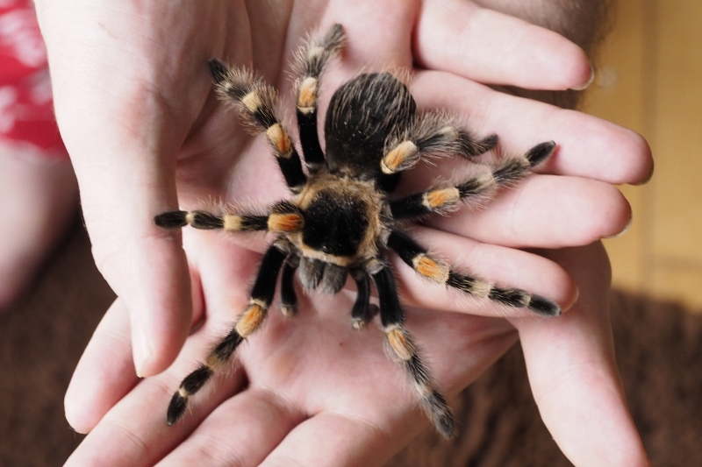
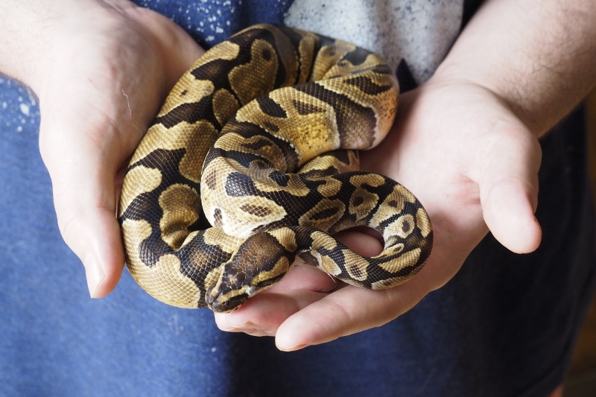
Charlotte (Mexican Red-Knee Tarantula) and Monte (Ball Python) are two safe and friendly creature teachers.

Activity | Description | Length
Meet Charlotte/Monte | Learn about characteristics and needs of living things with the help of two creature teachers! | 25 minutes
Discovery Hike | Learning goes outdoors – where the wild things live! | 45 minutes
Activities – digging, collection, scavenger hunt | Active and fun outdoor learning | 20 minutes
Let’s look closer! | Wrapup back in the classroom – what we learned! | 10 minutes

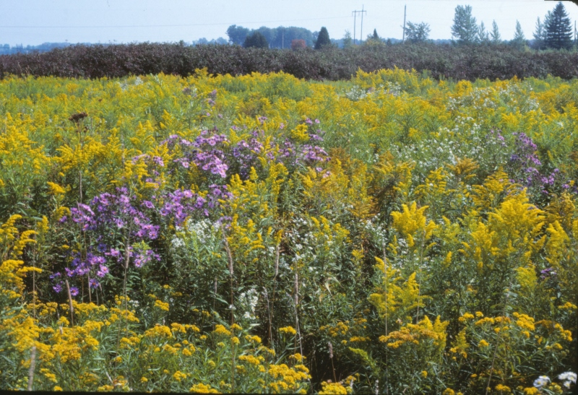
Multiple Programs
Repeating a program in a different season really enhances the students’ understanding of the study theme. From winter tracks in the snow to early fall great bug hunts, from kicking through October leaves to smelling flowers in spring, the changing seasons provide so many new experiences.

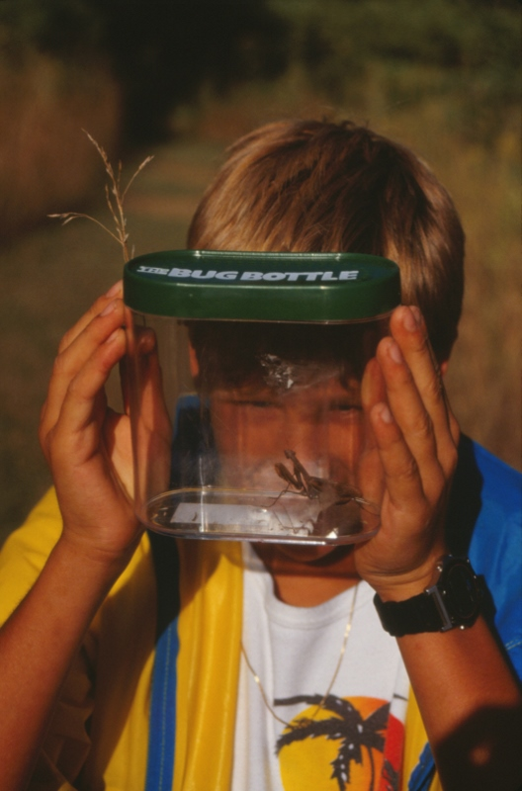
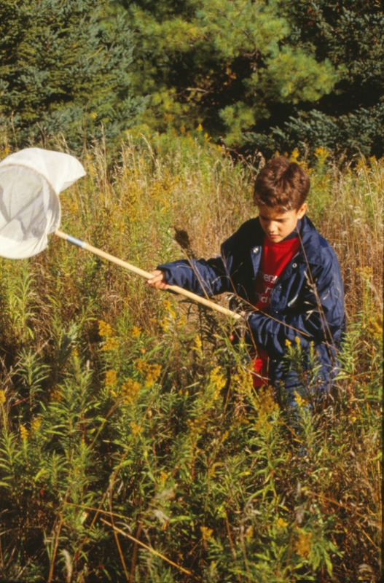
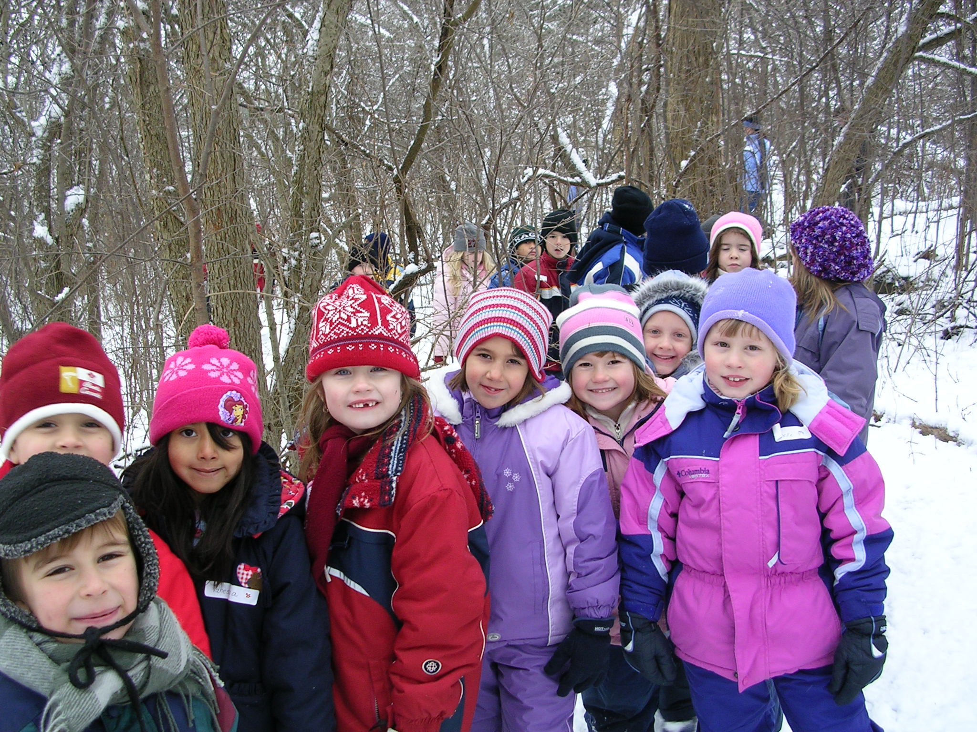

Contact Info
Email: dandanthenatureman@gmail.com
DantheNatureMan.com

